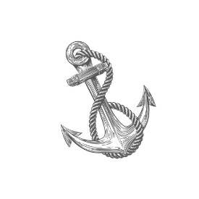
ANCHOR COUNSELING & WELLNESS, LLC
Rebecca G. Cowan, PhD, LPC, NCC, DCC
anchorcounselingwellness@gmail.com
anchorcounselingwellness.com
_________________________________________________________________________

RELEASE OF INFORMATION

This release of information remains in effect for 12 months after the date signed.

Client Information
Name: | Date of birth:
Address: | Phone:

Please accept this authorization for Dr. Rebecca Cowan to provide information about: (check relevant)

- my attendance in counseling sessions only
- information that may help those listed below work with me
- my attendance for the purpose of billing only

The below named person(s) and/or facility is permitted to communicate with Dr. Rebecca Cowan:

Contacted Party
Name: | Phone number:

Address:

Name: | Phone number:

Address:

NOTE: This release is subject to revocation by the undersigned at any time except to the extent that action has already been taken in reliance thereon. Revocation must be submitted in writing.

________________________________________________ _____________
Client Signature Date

